## Monitor and assess multiple hazards

You can monitor multiple hazards in DisasterAWARE. A hazard is displayed in the system when an occurrence or incident poses substantial threat to people, property, or assets as determined by disaster management authorities.

We continue to add new hazard types as reliable information becomes available.

### ****Hazard types, symbology and meaning****

Below are the types of hazards icons that you may see displayed on the map.

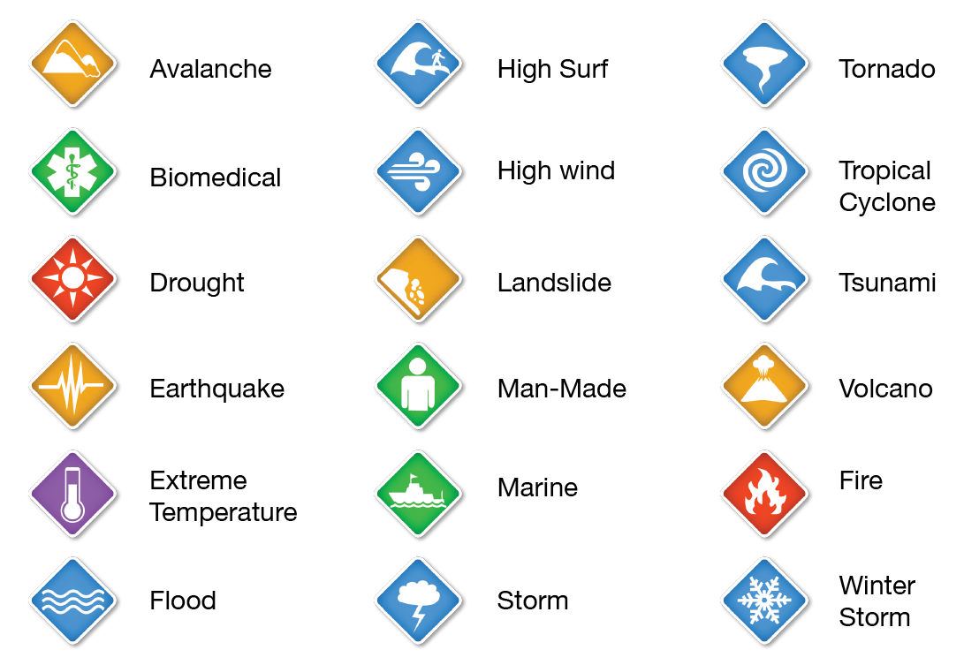  
  
Hazards are encoded with additional symbols and colors to indicate the type of occurrence and severity.

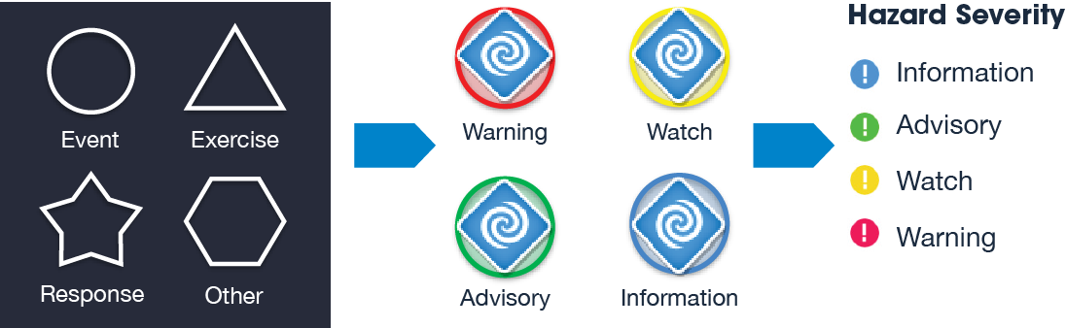

## How to locate hazards

There are several options for locating specific hazards.

### View the active hazards list

Click on the **Hazards Icon** on the toolbar. The **Hazards Panel** will open, displaying a list of active hazards within DisasterAWARE. By default, the most recently updated hazard will appear at the top of the list. You may zoom to a hazard in the list by clicking the “Go to” coordinates in the list.

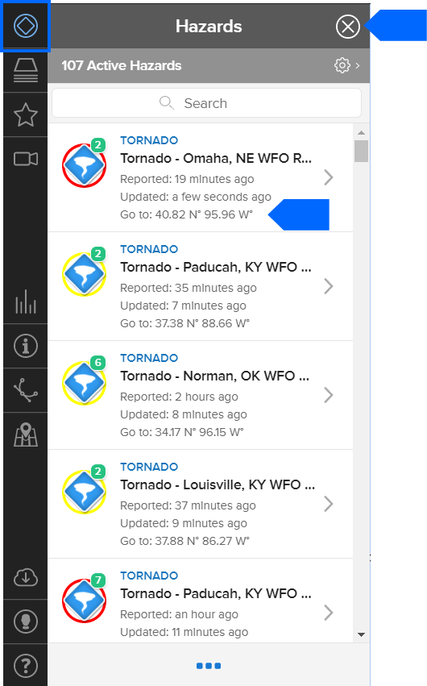

### Pan and scroll the map to identify hazards

Place your cursor over the map and then click and drag to pan the map for hazards.

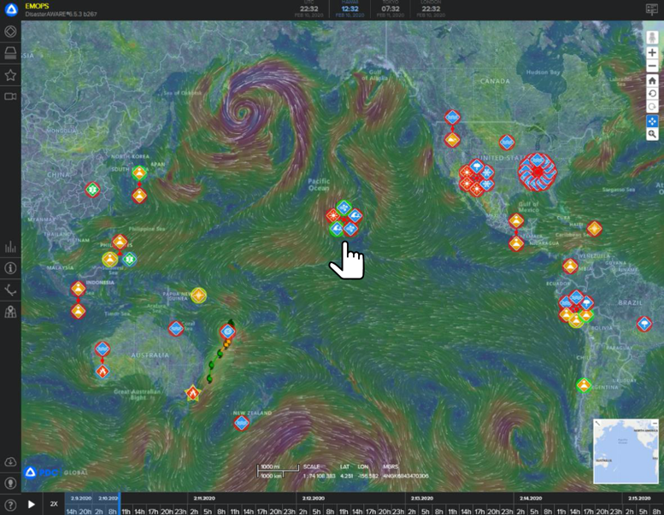

### Search by hazard name or location

Within the **Hazard Panel**, use the **Search** field to quickly search by name, location or type of hazard.

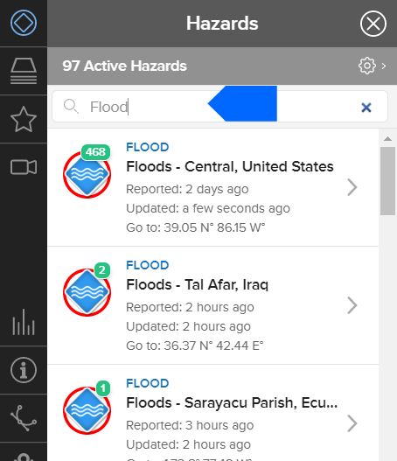

### Search for hazards in specific location

Click the **Map Locator** icon on the left toolbar. Search by location name or by entering coordinates. Click on the location in the results to zoom that location and see hazards in the surrounding area.

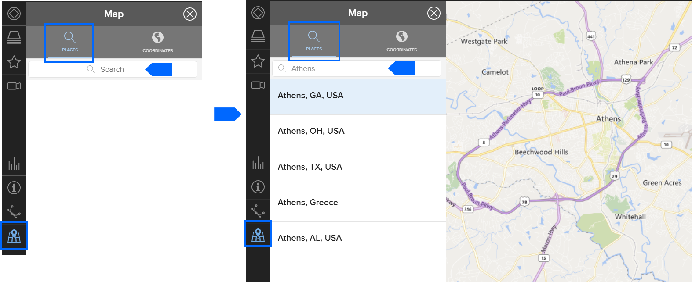

## Assessing hazard impacts

There are several tools to help you assess the potential impacts of hazards. To quickly view these tools, click a **Hazard Icon** on the map.

Upon clicking any hazard icon, a hazard tooltip appears. The tooltip provides quick links to **Products**, **Info**, **Layers**, and **Area Brief.**

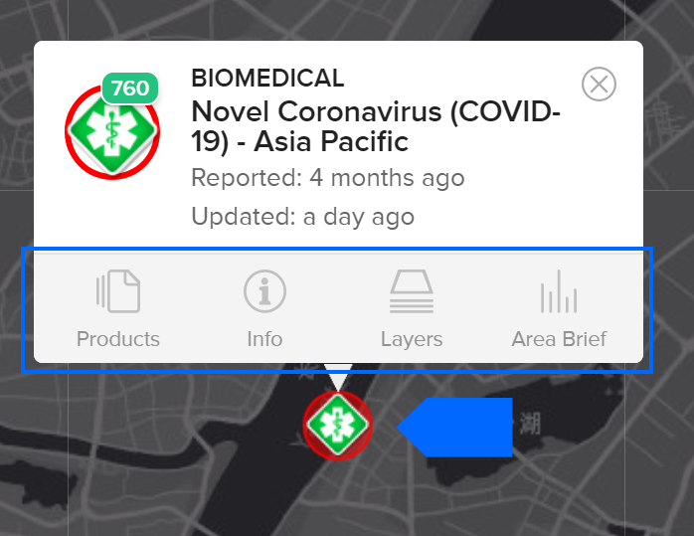

Note: You may also access these features by clicking a hazard in the hazard list:

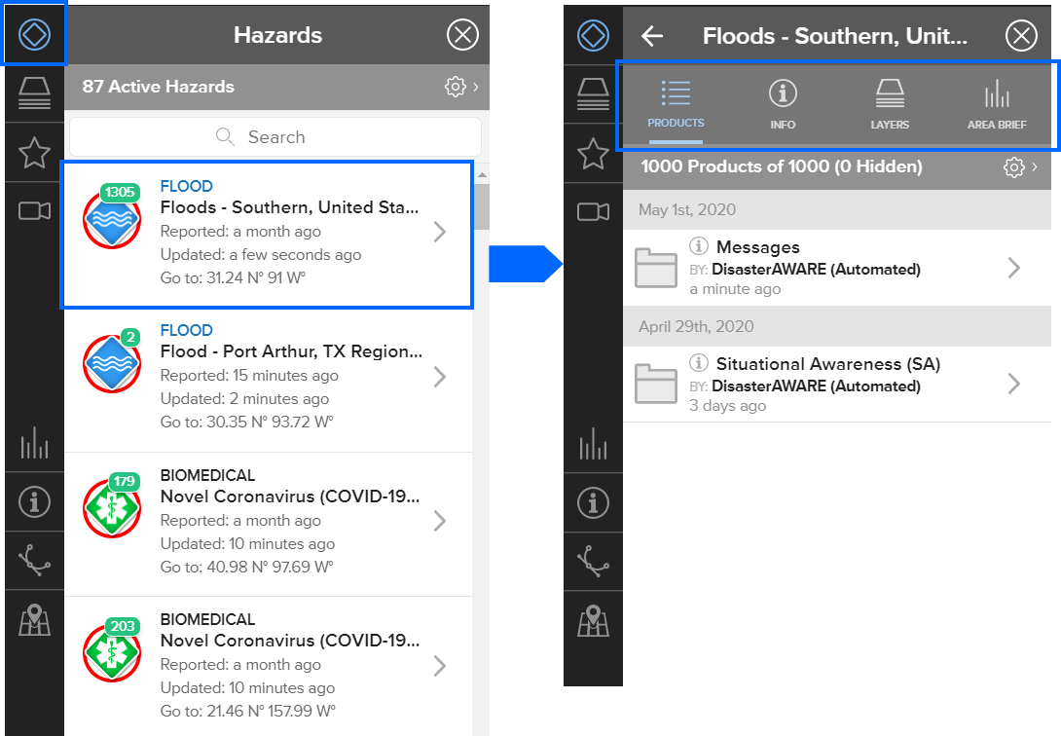

### Products

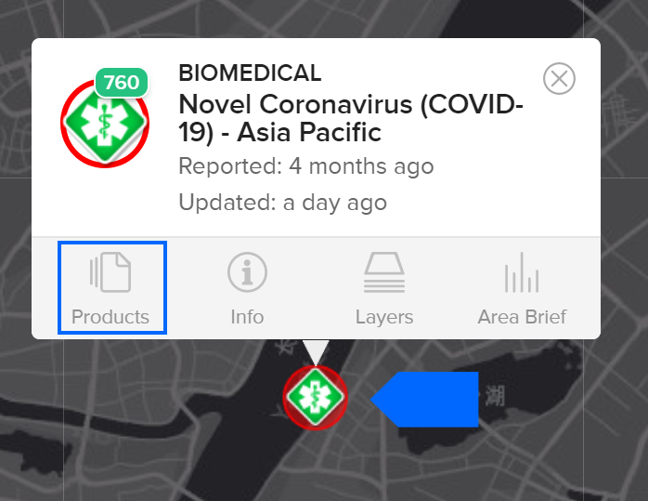

The **Products** link provides access to a variety of reports, custom maps, analyses, and other information shared by multiple agencies about the hazard. Below is an example of product types:

* **Situational Awareness Products** (for specialized maps, analyses, modeled impact assessments)
* **Situation Reports** (for detailed agency updates of the situation on the ground)
* **Damage and Needs Assessments** (for response and recovery planning)
* **Reference Maps** (for response and recovery planning)

By default, products listed and grouped by category and organized into subfolders by the organization who authored the products.

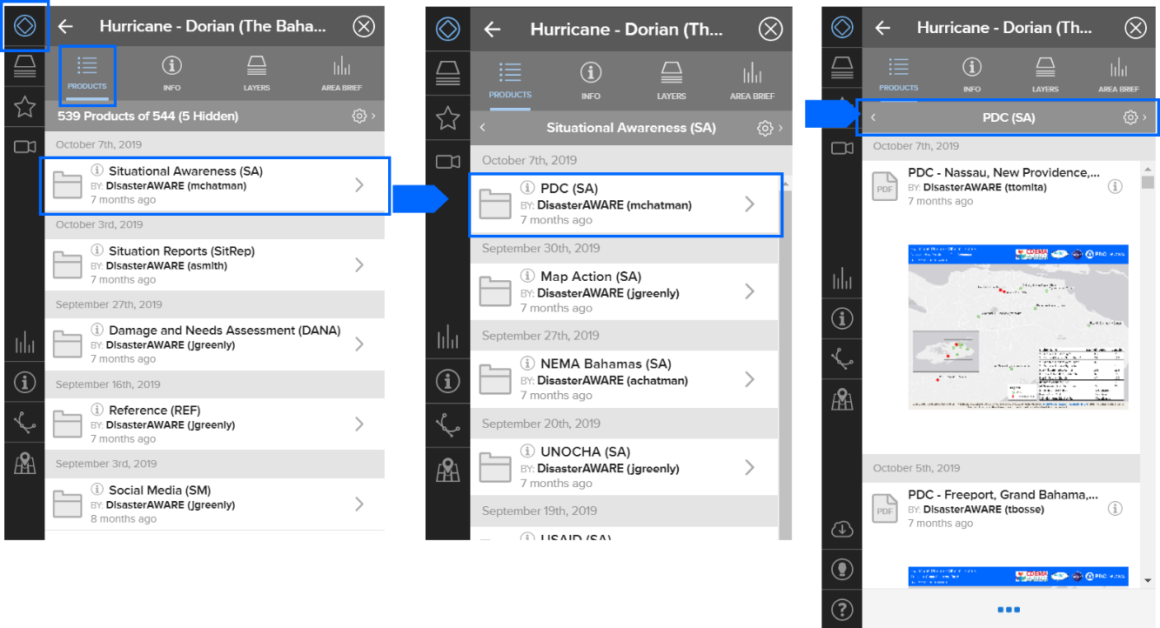

You can adjust the display of the products list by clicking on the **Settings** icon. You will find several options including the ability to sort products by time period and name.

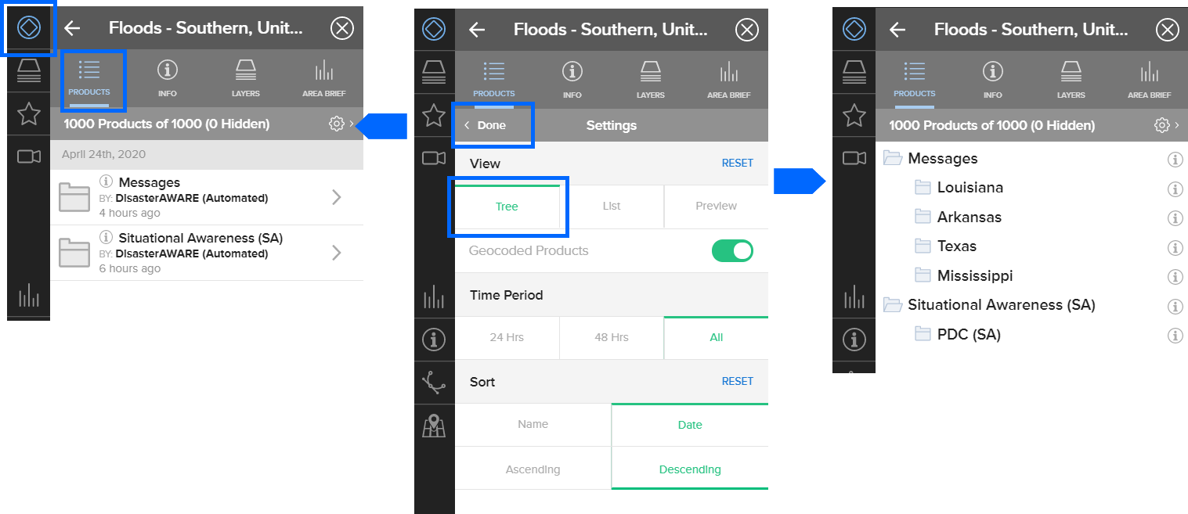

### Info

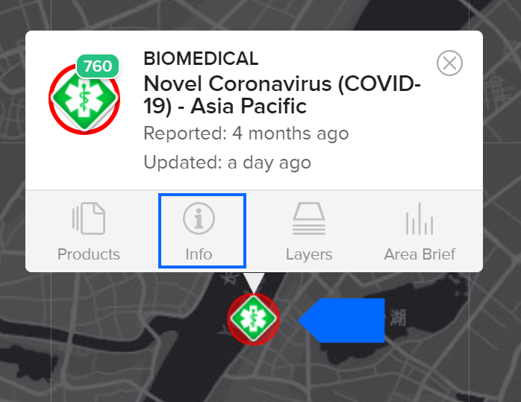

The **Info** link contains the latest advisory information issued by authoritative agencies along with potential impact information provided by PDC’s All Hazards Impact Model.

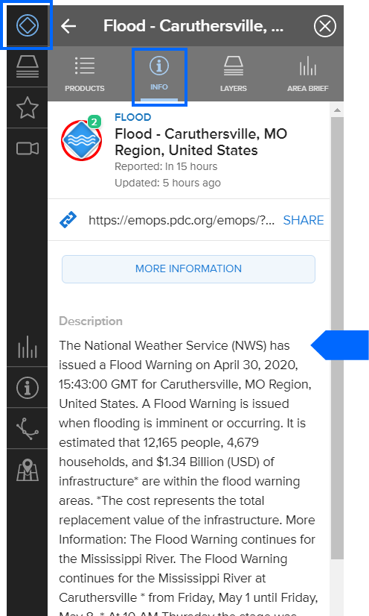

Click the **More Information** button to see **Hazard Brief**—a summary report detailing potential impacts.

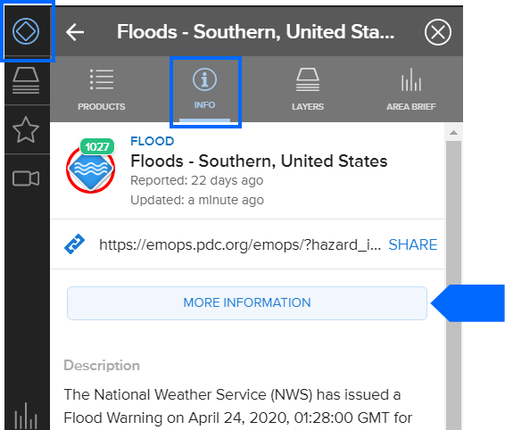

**Hazard Brief** summarizes potential impact estimates for vulnerable groups, buildings and infrastructure, and more.

### Layers

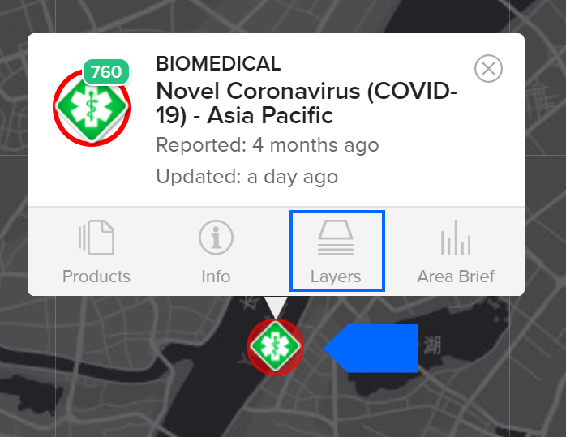

The **Layers** link allows you to view default hazard layers and explore other pertinent layers to help you assess the severity and potential impacts of a hazard.

For example, the **Ash Cloud 6 Hours** layer shown on the map below details the spread of volcanic ash in Reventador, Ecuador, after an eruption. This information quickly highlights where at risk populations and at risk infrastructure, such as airports, are located.

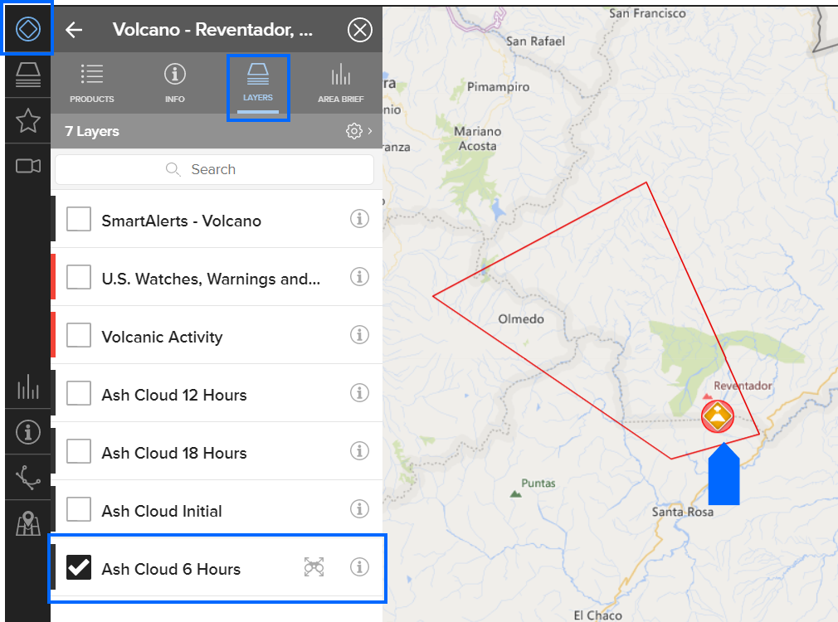

The Information icon for the layer provides the authenticated source of the data.

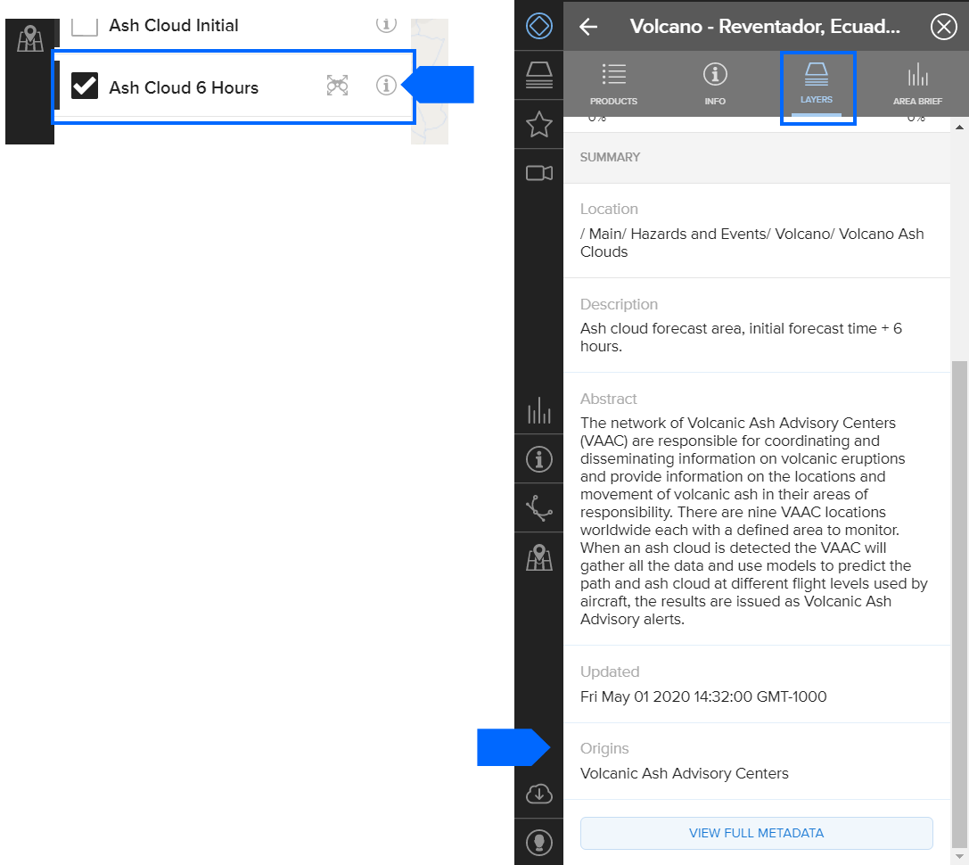

### Area Brief

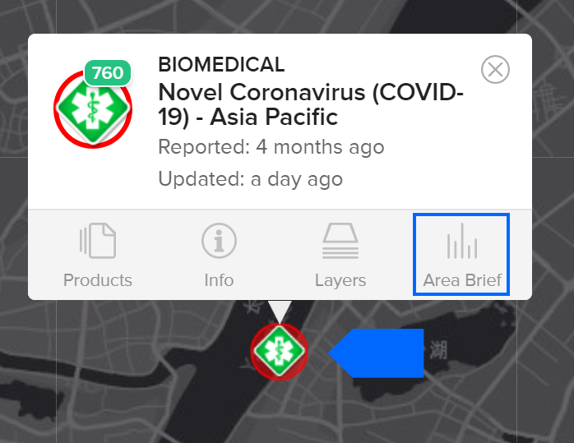

The **Area Brief** link provides access to a detailed situational awareness report which includes the overall exposure of populations to the hazard, critical infrastructure, meteorological observations, risk and vulnerability, and more.

